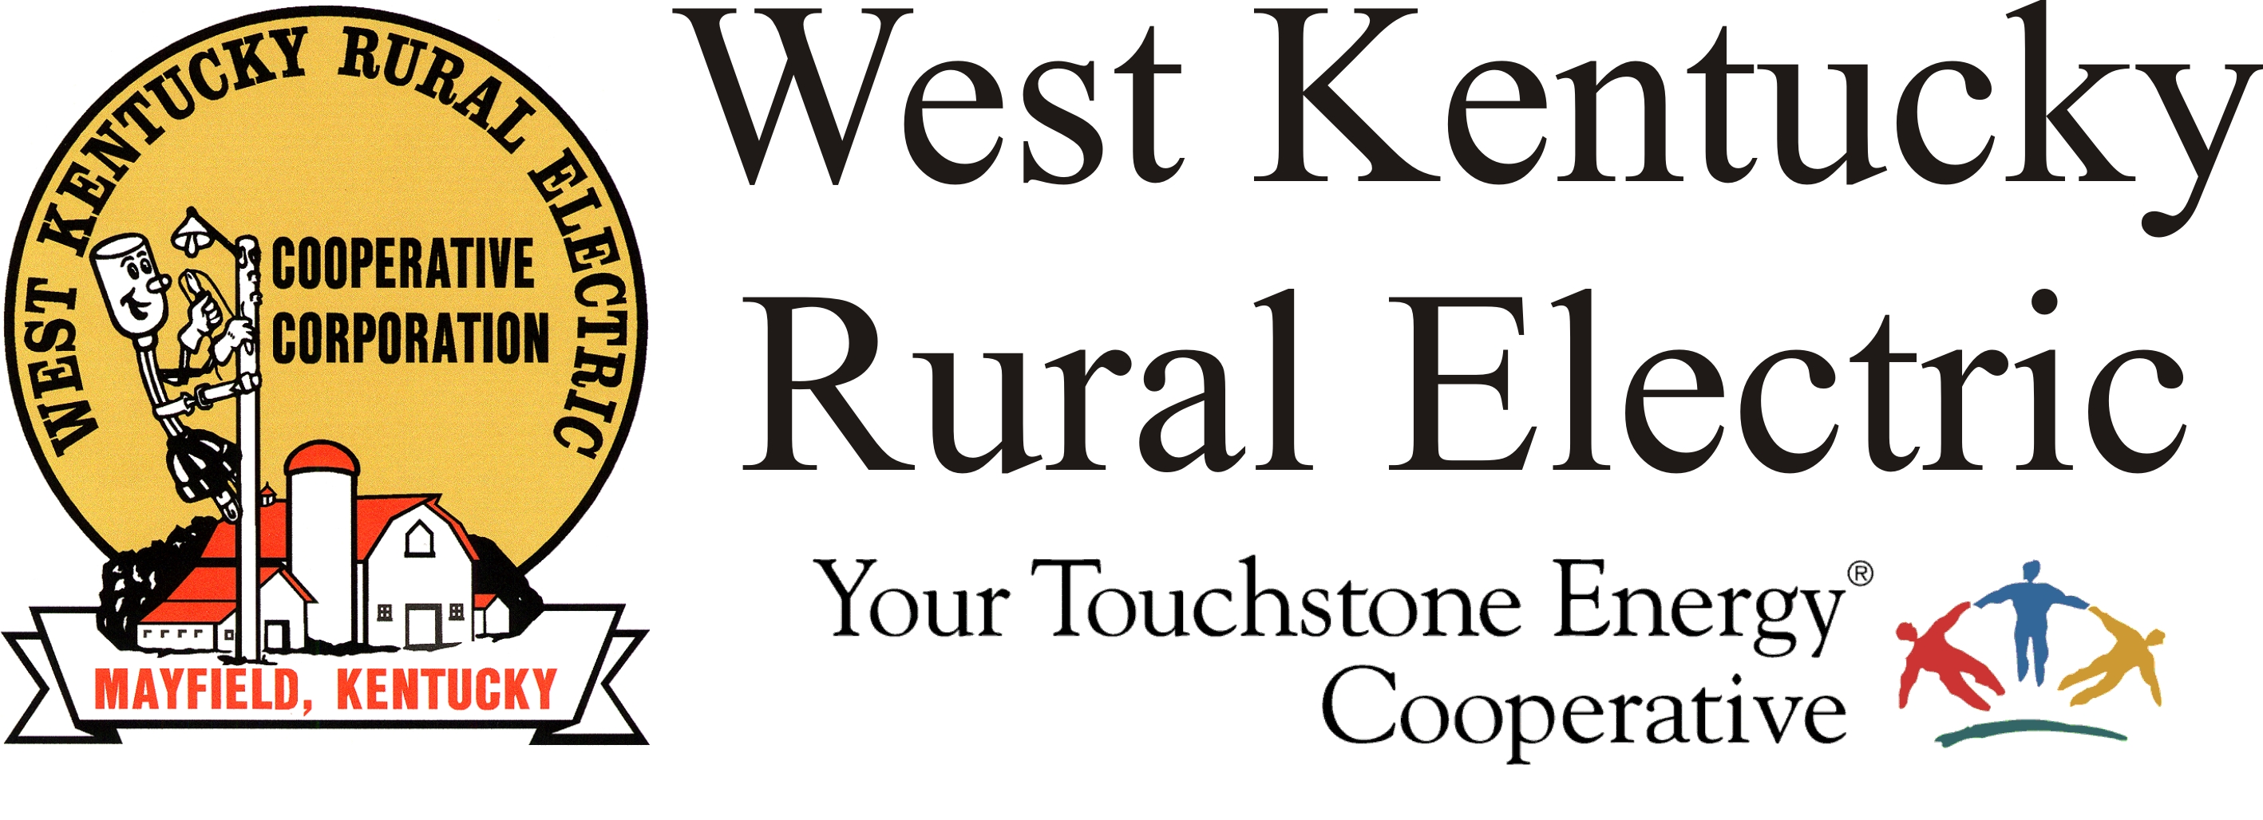

West Kentucky RECC Sunday Afternoon
Storm Damage Update

(Mayfield, Ky.) Dec. 12, 2021 (2:30 p.m.) – We’ve made great progress since our last update. The lights came on for more than 20,000 members as TVA powered up seven more WKRECC substations, leaving us with just two stations still without power. The substations without power are John Ed Walker, which serves the Mayfield area, and Hickory Grove, which serves northern Graves County. TVA continues working to restore transmission to these two remaining subs, however, the damage is more serious and will take longer to rebuild.

Outages within the areas where substation power has been restored are likely due to damage resulting from the storms. We have more than 20 crews out across the service area today making repairs and will continue working around the clock until repairs are complete.

We will have an update on the total number of members without service on the evening update.

Our communication problems continue. The phone system remains inoperable. Our website is back up, but the outage map continues to be inaccessible.

Please stay off the roads. Heavy traffic from sightseers is distracting and dangerous to lineworkers and first responders.

For those in areas with outages, we continue to urge members with electric-powered medical devices to relocate or secure a generator or an alternate power source.

Read our generator safety reminders here: https://www.wkrecc.com/index.php/safety/electrical-safety/generator-safety

###

Georgann Lookofsky
270-804-1701
glookofsky@wkrecc.com

